Progress update on the construction of the Barrow Blueway

Construction work on the Blueway is proceeding well. The Ecological Clerk of Works is in regular contact with site staff ensuring that correct procedures are being followed.
On the North Kildare Section (Ballyteige to Glenaree) 1.6 of the 4km section is complete with compacted stone and 804 and is ready for the finishing layer of quarry dust. A further 700m has been excavated and filled with the formation layer of compacted stone.
On the southern site (Milltown Bridge to Kildare/Laois border) the base layer is complete on approximately 2.3km of the 3km length. Works in the vicinity of Milltown Bridge will be proceeding over the next few days. This section requires archaeologal supervision and the Ecological Clerk of Works will also be in attendance because of the presence of tree roots close to the surface.
The base layers are laid to a width of approximately 2.8m and will be narrowed to 2.5m when the final surface is complete.

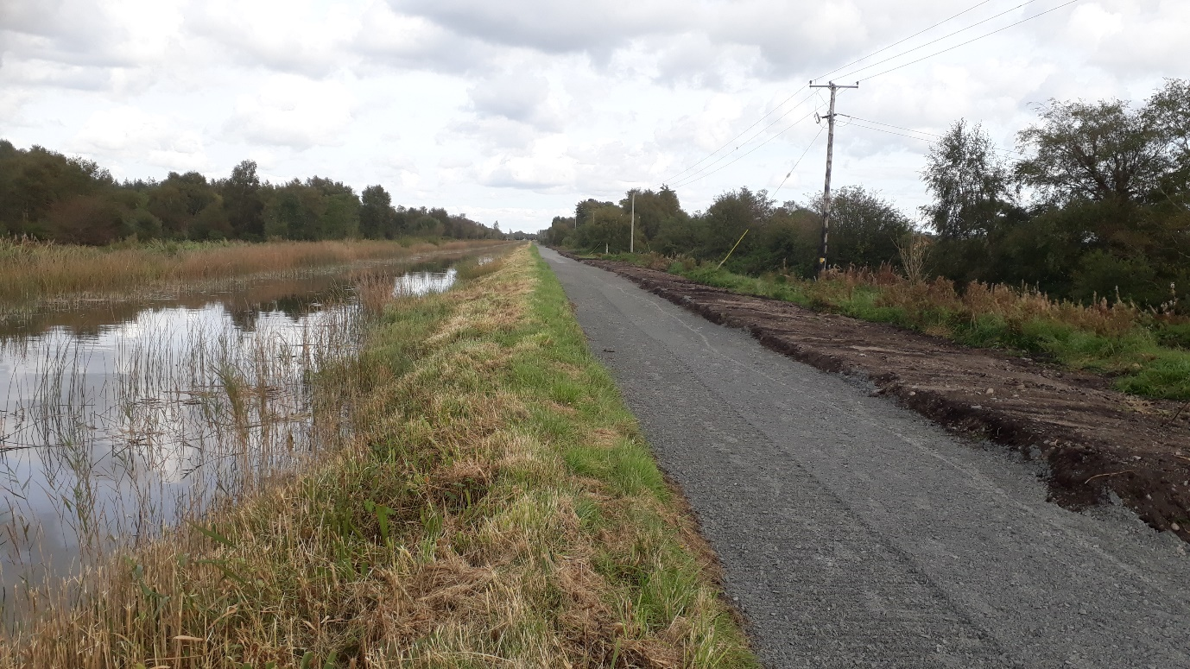
Northern Section - pathway complete and ready for final surface

